**A**

**Questions of**

**FIRST AID BY ELECTRIC SHOCK**

**(how to properly provide help in an electric shock)**

1. If the CPR (cardiopulmonary resuscitation) is provided with rescue breaths what is the

correct ratio between chest compression and rescue breaths?

1. 3 rescue breaths per minute;
2. 2 rescue breaths every 30 chest compressions;
3. 60 to 80 rescue breaths per minute.
4. If the victim stays unconscious for 30 minutes or longer;

2. CPR (cardiopulmonary resuscitation) may be terminated:

1. In case that the victim starts to breathe or awakes;
2. In case of the doctor's instruction;

3. What is the correct ratio of CPR (chest compression)?

1. 10 to 12 chest compressions per minute;
2. 100 chest compressions per minute;
3. 130 chest compressions per minute.

4. CPR (cardiopulmonary resuscitation) may be terminated

1. In case of total exhaustion of the rescuer;
2. After recovery of cardiac activity (victim starts to breathe normally);
3. If the cardiac activity is not restored within 5 minutes.
4. 1,2,4,3,6,5

5. Select the correct procedure for first aid procedure in case of electric shock

1. 1 , 4 , 5, 3, 6, 2
2. 1, 5,6,4,3,2 **Steps:**
3. extricate the victim out of the electrical circuit (turn off power supply);
4. notify the supervisor as soon as possible and prepare a record of the accident;
5. if necessary, commence CPR (the rescue breaths are optional);
6. check response, clean airways, determine whether the victim is breathing;
7. call a medical help (do not leaving the victim alone);
8. treat any secondary injuries.

6. Before starting CPR, during check the breathing, the following is necessary:

1. Check&clean the airways;
2. Lay the victim on a soft pad;
3. Lean the victim's head back.

7. Before commencement of CPR it is necessary:

1. to lay the victim on his/her back on the soft and flat pad;
2. to provide the victim a drink (water);
3. to lay the victim on his/her back on the rigid and flat surface;
4. upper limbs are stretched in the elbows;

8. The rescuer position during the CPR shall be as follow:

1. upper limbs are bent at the elbows;
2. one hand is inserted under the back of the victim and the other hand is used to provide CPR;

9. When performing chest compressions (CPR), the chest compression shall be made as

follow:

1. to a depth of 4-5 cm;
2. up to a depth of 2 cm, to avoid damage of victim's sternum;
3. a rate of about 100 compressions per minute.

10. If the victim remains conscious/awakes from unconsciousness after electric shock, he/her is not visibly injured, breathes normally:

1. it is highly recommended to call a doctor, or bring him to the medical check;
2. may continue to work, but no later than 24 hours, he should see a doctor;
3. the supervision shall be performed (the victim shall not be left alone).

11. When an accident in the electrical systems above 1000 V occurs (especially in the fall

of MV/HV wires), it is necessary to carry out rescue work prudently, because:

1. before carrying out rescue operations, it is necessary to issue the command "B" (acc. to Czech standards);
2. the injury must first be announced to the workers of the nearest substation;
3. there is a risk of the step/touch voltage occurrence.

12. It is possible to extricate the victim out of the electrical circuit (out of reach of current)

by the following way:

1. pulling out the affected person using insulated rescue hook or similar tool;
2. turning off the power supply;
3. sliding/pushing the source of injury (eg bare conductors out of the victim's body) using insulated rescue hook or similar tool.

13. **Emergency** medical service in Czech Republic can be contacted using the emergency telephone number

1. 150;
2. 155 or 112;
3. 158.

**B**

**Questions of**

**QUENCHING THE FIRE**

**(how to properly extinguish of electrical equipment)**

14. In the event of fire in laboratories FEECS, students/crew shall immediately announce

the fire at the telephone number...

1. mobile No. 596 991 111, internal telephone No. 1111;
2. mobile No. 596 992 121, internal telephone No. 2121;
3. mobile No. 596 993 111, internal telephone No. 3111.

15. The extinguishing the electrical equipment which is, or may be live, due to risk of injury

caused by electric shock, is impossible to perform using:

1. Water-type fire extinguisher;
2. Foam-type fire extinguisher;
3. Powder-type fire extinguisher.

16. Mark the possible risks to people in case of fire occurrence in the indoor areas:

1. Suffocation by toxic smoke;
2. Loss of orientation and subsequent unavailability to find escape path caused by low visibility;
3. Burn of people;
4. Panic with subsequent risk of impossible proper evacuation.

**C**

**Questions of**

**COMPETENCES OF STUDENTS**

**ON UNIVERSITY LABORATORIES**

**(what the student is allowed to do while working
  
in the laboratories and what is forbidden)**

17. University students working in Laboratories of Faculty of Electrical Engineering and

Computer Science are considered as instructed persons (§4 acc. To Decree 50/1978 Coll.), provided that they:

1. are trained from First aid procedure and acquainted with risks that electricity may create, usually provided in lectures held in "Safety at electrical engineering" subject;
2. are trained from local safety rules for each particular laboratory where they perform work activities, emphasizing particular risks and operation rules;
3. simply commence the study at University (no further condition is needed).

18. University students working in Laboratories of Faculty of Electrical Engineering and

Computer science are considered as instructed persons (§4 acc. To Decree 50/1978 Coll.), they are allowed to perform these activities:

'a) work in the vicinity of live parts (20 cm) with inspection of supervisor.

1. perform live working without any restrictions.
2. in general they are not allowed to perform live working except of measurement and approved simple work procedures.

19. The limit of ELV (extra low voltage is in normal areas — i.e. dry non-conductive areas)

for insulated conductors and/or equipment protected against unintentional touch by e.g. enclosures:

1. 50 VAC and/or 120 V DC;
2. 25 VAC and/or 60 V DC;
3. 12 VAC and/or 25 V DC.

20. Mark the work activities which are banned to students in school laboratories:

1. Perform live working (except of measurement and approved simple work procedures);
2. Perform dead work activities with prior acceptance/approval of the supervisor;
3. Perform any work activities in the school laboratories without prior noticing/agreement of the supervisor.

**0**

Questions of

**IDENTIFICATION OF**

**CONDUCTOR/TERMINALS AND MMI**

|  |  |  |
| --- | --- | --- |
|  |  |  |
| 21 Connecti)r with the sign | or marked as **PE...** |
|  |
|  |  |

1. is intended for the neutral conductor connection of supply network;
2. is the information that "noiseless ground" is present here for functional earthing;
3. is intended for connection of the **PE** wire, which may be connected to an electrical equipment;
4. is intended for connection of the **PE** wire, which shall (i.e. must) be connected to an electrical equipment.

22. Insulated PEN conductor used in TN-C supply systems is marked with the color...

1. brown;
2. light blue.
3. black with blue sleeves at the ends of the cable;
4. green/yellow with blue sleeves at the ends of the cable.
5. brown;

23. Insulated neutral (N) conductor is marked with the following color:

1. light blue;
2. black with blue sleeves at the ends of the cable;
3. green/yellow with blue sleeves at the ends of the cable.

24. The green-yellow coloured conductor may be used for marking:

1. of any conductors (i.e. phase, neutral, PE);
2. only for PE conductors;
3. for PE conductors and in exceptional cases for neutral conductors (N).
4. of any conductors (i.e. phase, neutral, PE);

25. The light blue coloured conductor may be used for marking:

1. only for neutral conductors;
2. for neutral conductors and in exceptional cases for PE conductors.

26. The orange coloured conductor is used for marking:

1. of any conductors (i.e. phase, neutral, PE);
2. only for neutral conductors;
3. for phase conductors that stay live even in case of main switch tripping.

27. The black insulated conductor:

1. shall not be used for other function than a live wire.
2. shall not be used for other function than a neutral wire.
3. is in extraordinary situation possible to change its function to another function using durable mark signs.

28. Choose a correct connection of flexible cord cable between electrical appliance and socket-outlet and the socket-outlet connection in **TN-S** supply system.

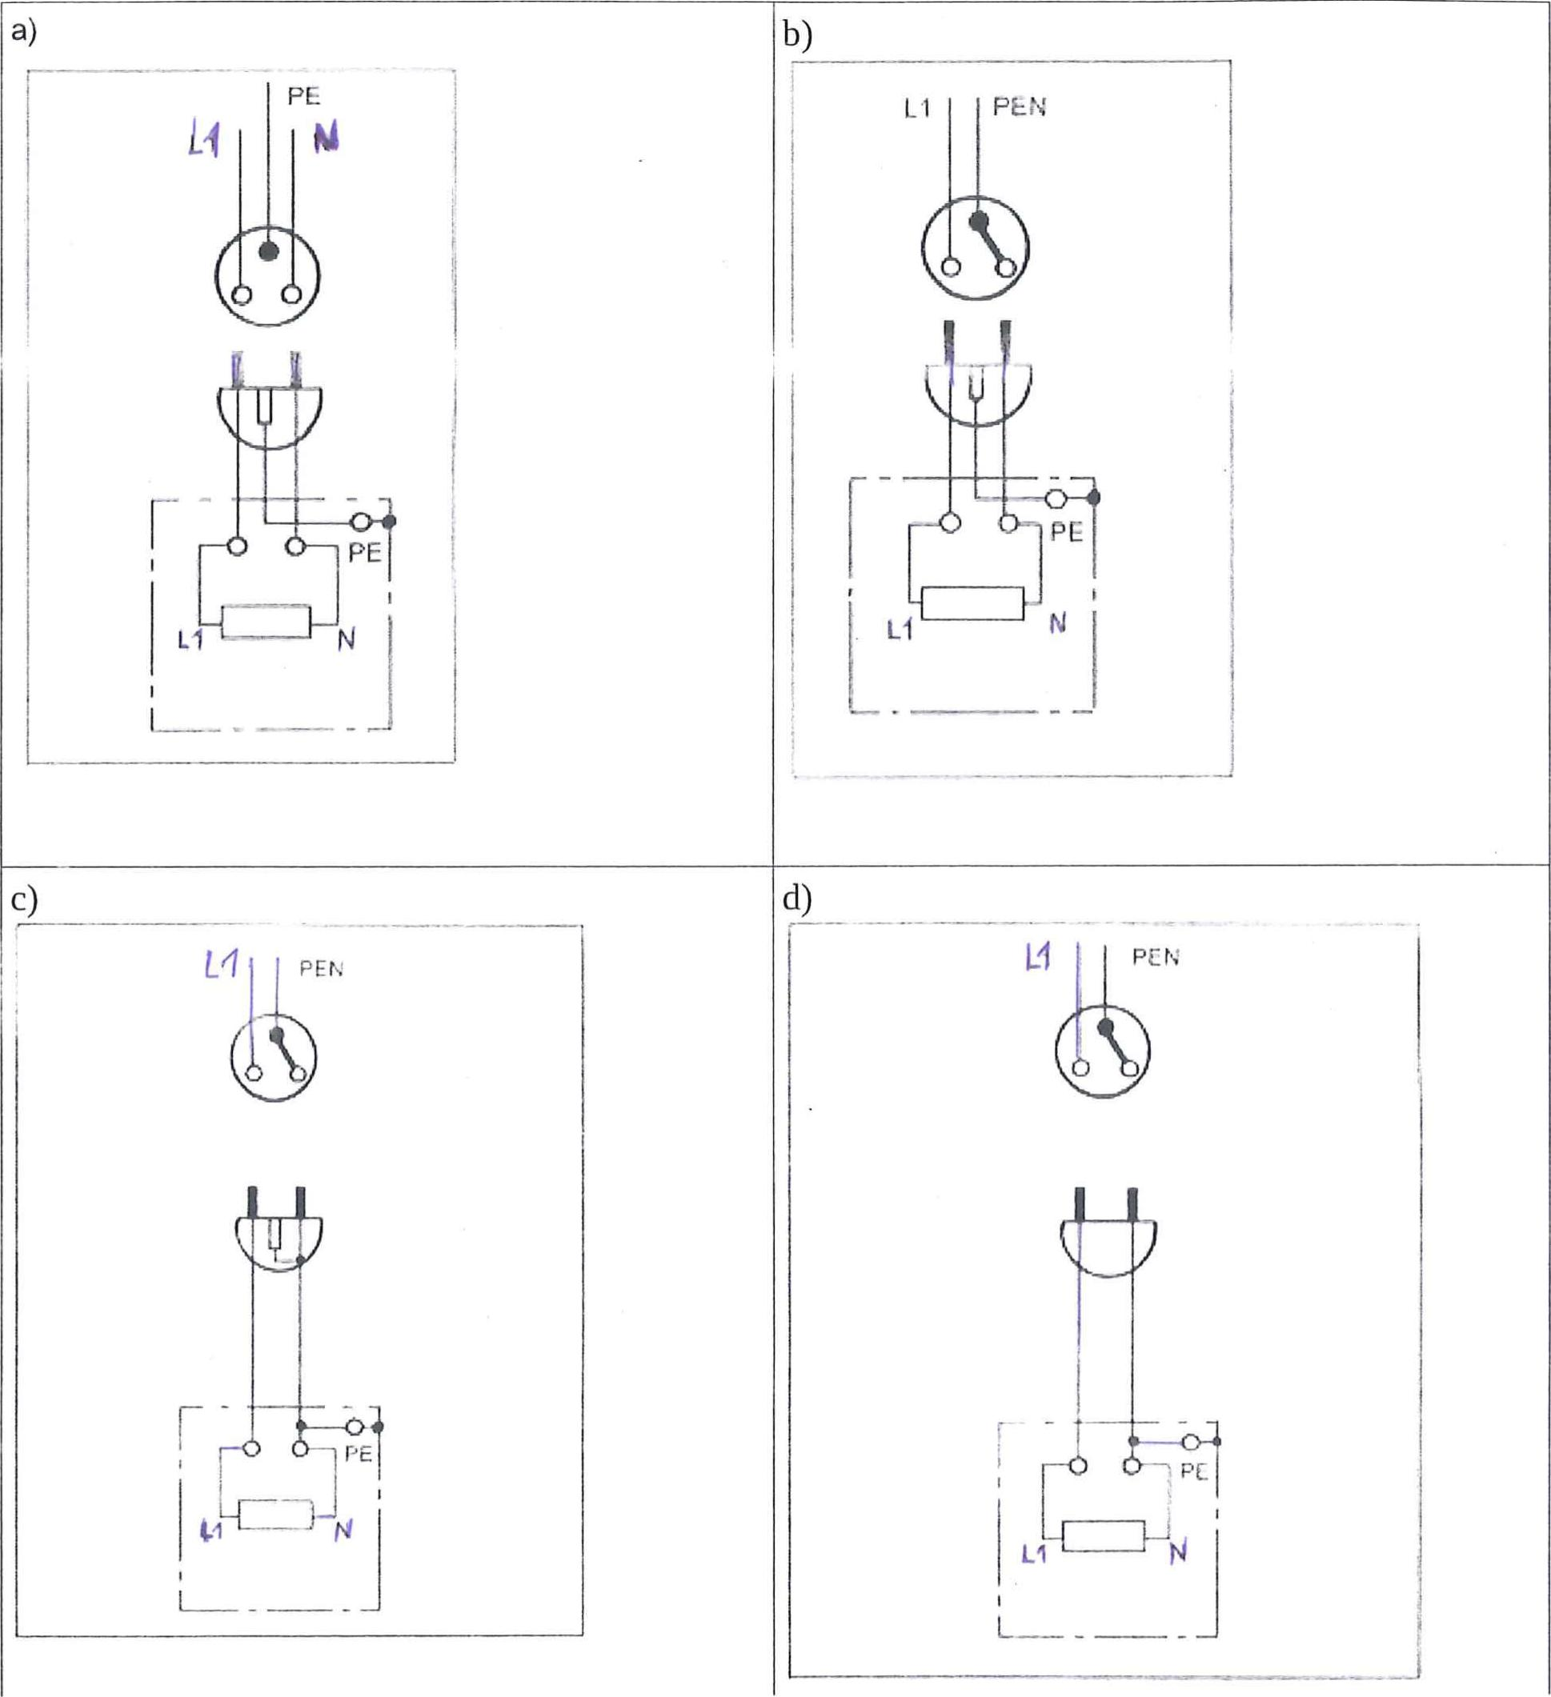

L1 I I PEN

1-1

PE

P

1_1

PEN

Li

PEN

PE

**29.** Three persons in Figure 1 labeled A, B, C, touched parts (marked in the figure) of the electrical equipment in the TN-C network. Draw the complete trace of electrical current that flows from power source through human body, resulting an electric shock.

*(Note — Do not draw here, draw into the test paper, where the figure is present also)*

**TN-C** (supply system)

**' 7.7! , I 4 5 4.. S 0,01,.ir ei**•

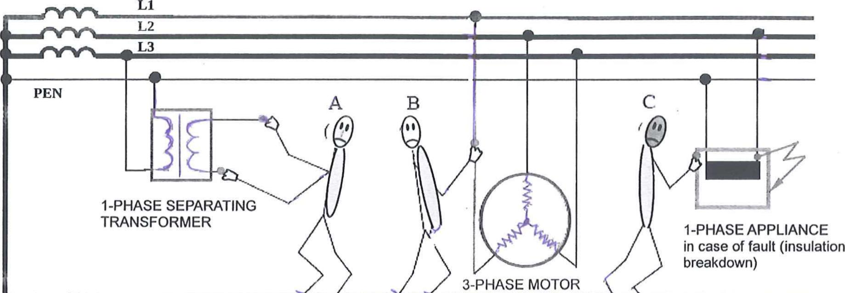

**PEN**

1-PHASE SEPARATING TRANSFORMER

1-PHASE APPLIANCE

in case of fault (insulation breakdown)

**LI**

L2

**L3**

**A**

3 PHASE MOTOR

* ■•■

**,,1_,P.,;"•.: • - *.. • C Lti• • .1/4.1.7,•:.111 .1.17 "•••••-•,. 4* :111 er. "J" • "e**

**_.,„** .;

* .. **41**

**EARTHING ARRANGEMENT Figure 1**